**ER Diagram of Contact Application**

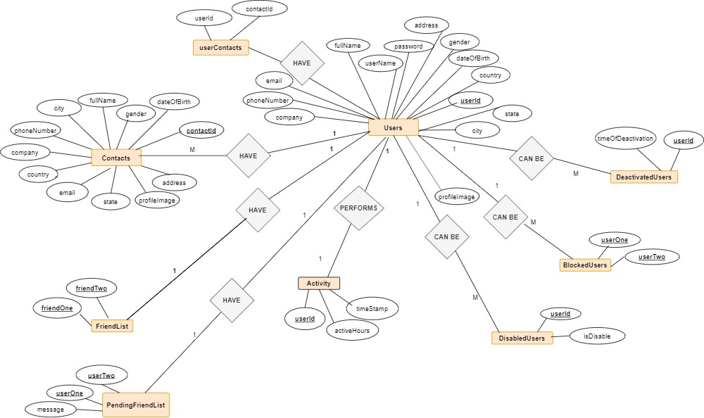

https://drive.google.com/drive/u/0/folders/131iArWj0ol0226fPnzC4Y6MumfBqsaSI 1/2